TITAN Invoice Approval Guide for Accounts Payable
For Office Admin and authorized AP users
Purpose Use TITAN to upload an invoice once, assign it for coding and approval, track exceptions, and preserve the completed accounting record.
When you finish You will be able to move an invoice from intake through posting, payment, and archive without emailing or rescanning the paperwork.

Before You Start
- Sign in to TITAN with an account that has Invoice Approval access and AP permissions.
- Have the original invoice available as a PDF, JPG, or PNG. The maximum file size is 25 MB.
- Know the approver who should code and approve the invoice.
- A purchase order is optional. You can process a standalone invoice at any time.

The AP Workflow
Stage | AP responsibility | TITAN location
Intake | Upload, verify invoice data, and assign an approver | New Invoice
Approval | Monitor progress and respond to returns or disputes | Awaiting Signature, Returned to AP, Disputed
Closeout | Post, record payment, and archive | AP Closeout
Reporting | Search, filter, export, or review history | All, Archive, report controls

Upload and Assign an Invoice
- Open the module. From TITAN, open Invoice Approval and Coding.
- Start a record. Select New Invoice.
- Choose a PO if applicable. Select a purchase order or leave No PO selected. A PO is not required.
- Select the file. Upload the original invoice. TITAN reads supported invoices and suggests vendor, invoice number, dates, and total when possible.
- Review every field. Confirm vendor, invoice number, invoice date, due date, amount, optional location, and AP notes. Correct any extracted value before submitting.
- Assign the approver. Choose the manager, owner, administrator, or other authorized approver responsible for this invoice.
- Submit. Select Upload and Assign. TITAN preserves the original file and notifies the assigned approver by the configured channels.
Important Automatic extraction helps with data entry, but AP remains responsible for verifying the invoice against the source document.
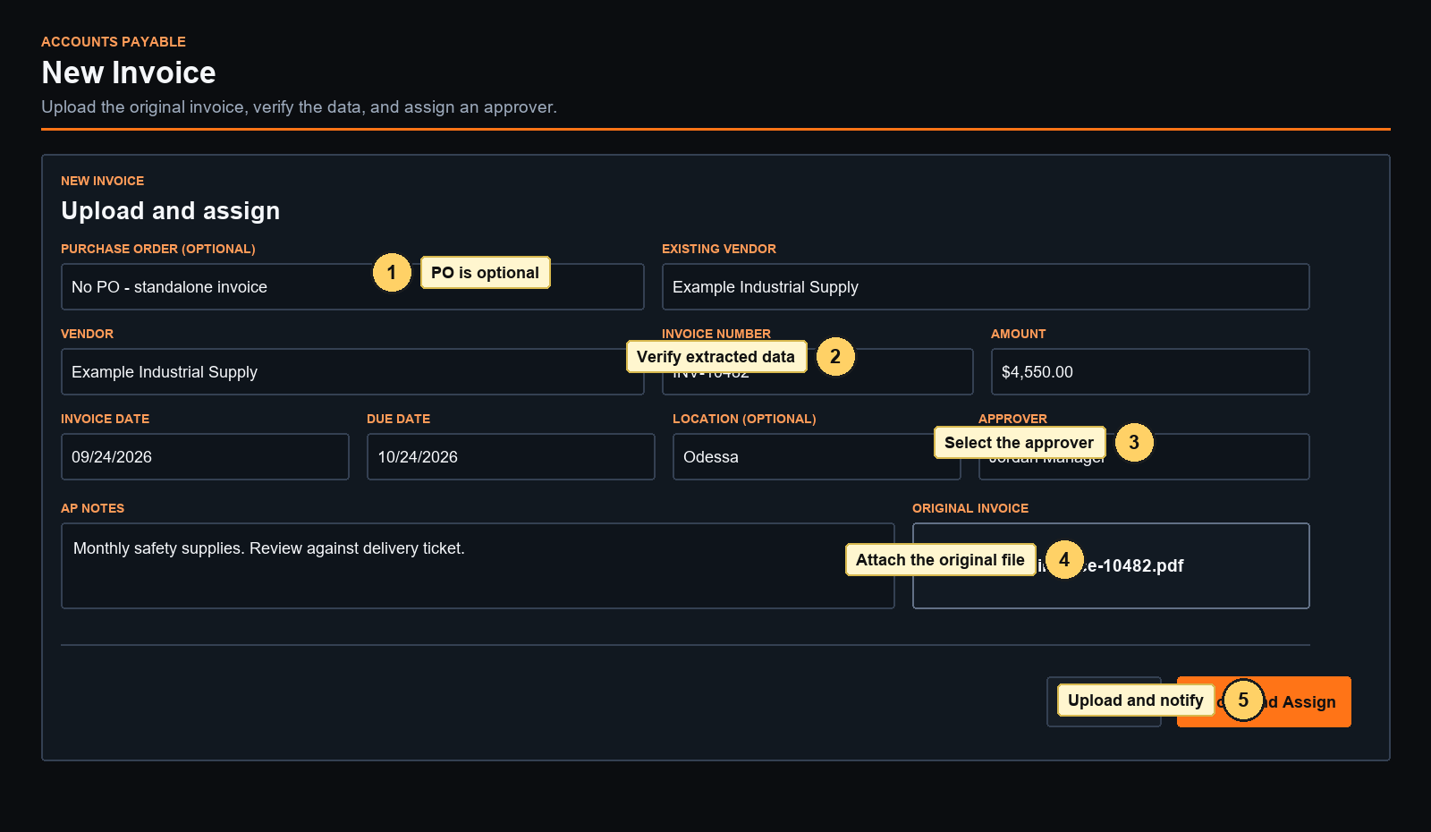
Figure 1 New Invoice form
1 optional PO | 2 verify extracted fields | 3 choose approver | 4 attach original | 5 upload and notify

Using an Optional Purchase Order
- No PO Leave the PO field blank. The invoice follows the normal approval and closeout workflow.
- Linked PO TITAN fills the PO vendor and location and suggests the remaining PO amount. Review the invoice amount because partial invoices are allowed.
- Matched The invoice fits within the remaining authorized and received value.
- Pending receipt The PO does not yet show enough received value for the invoice.
- Variance The invoice exceeds the available PO value beyond the current 5 percent tolerance.
- Link or unlink Before approval, AP can link a standalone invoice to a PO or unlink a PO from the invoice record.
Current rule A PO warning is informational. It does not prevent the approver from completing the invoice, and invoices without POs remain valid.

Review Duplicate Warnings
- Review the possible match. TITAN compares vendor and invoice number against active records.
- Stop if it is a duplicate. Close the new upload and open the existing invoice.
- Continue only when valid. Enter a review note, confirm that you reviewed the warning, and submit. The acknowledgment is saved in history.

Monitor and Correct Invoices
View | What appears there | AP action
Awaiting Signature | Invoices assigned but not yet approved | Monitor, correct details, replace the current file, or reassign
Returned to AP | Approver sent the invoice back with a reason | Correct the record and assign it again
Disputed | Approver reported a vendor or invoice problem | Resolve the issue, document the resolution, and resend
AP Closeout | Approved, posted, or paid invoices | Finish accounting closeout
Archive | Completed paid records | Search, review, and export
Voided | Invoices removed from active processing | Review the retained reason and history

Correct a Record Before Approval
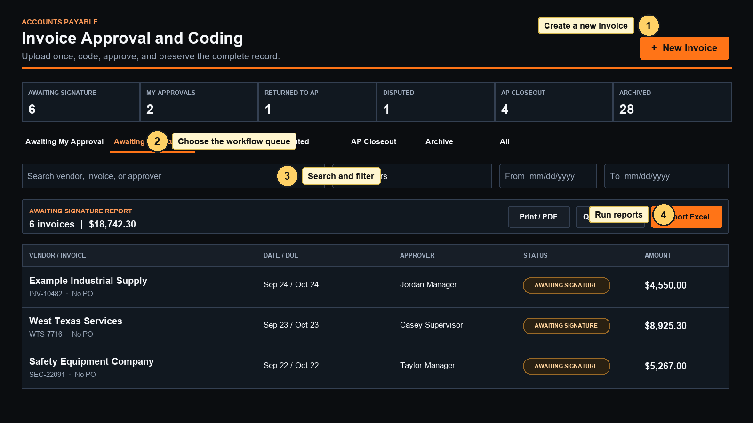
Figure 2 AP dashboard and reporting controls
1 start an invoice | 2 choose a queue | 3 search and filter | 4 print or export the filtered view
- Open the invoice and use Edit Invoice Details to change dates, amount, vendor, location, or AP notes.
- Use Upload Corrected Invoice when the source document changes. TITAN keeps the original file and records the corrected version as current.
- Use Assign or Reassign to send the invoice to another approver. The new approver receives an email and push notification when available.
- Use Void Invoice only when the record should leave active processing. A reason is required, and the record remains auditable.

Resolve Returns and Disputes
- Read the reason. Open the invoice and review the approver's return or dispute explanation.
- Correct the issue. Update invoice details, replace the invoice file, or contact the vendor as needed.
- Document the resolution. For a dispute, enter an AP resolution note that explains what changed or how the issue was resolved.
- Send it back. Choose the approver and return the invoice to the approval queue.

Complete AP Closeout
- Review the approval. Confirm the authenticated approval, coding, signed approval image, activity, and notification delivery.
- Download the packet. Use Approved Packet when a combined approval record is needed.
- Mark Posted. Enter the accounting batch, voucher, or posting reference.
- Mark Paid. Enter the payment date and check, ACH, or wire reference.
- Archive. Archive the paid invoice. The full record remains searchable.
Corrections Use Correct or Reopen Closeout when a posted, paid, or archived record needs correction. TITAN requires a reason and preserves the prior values in history.
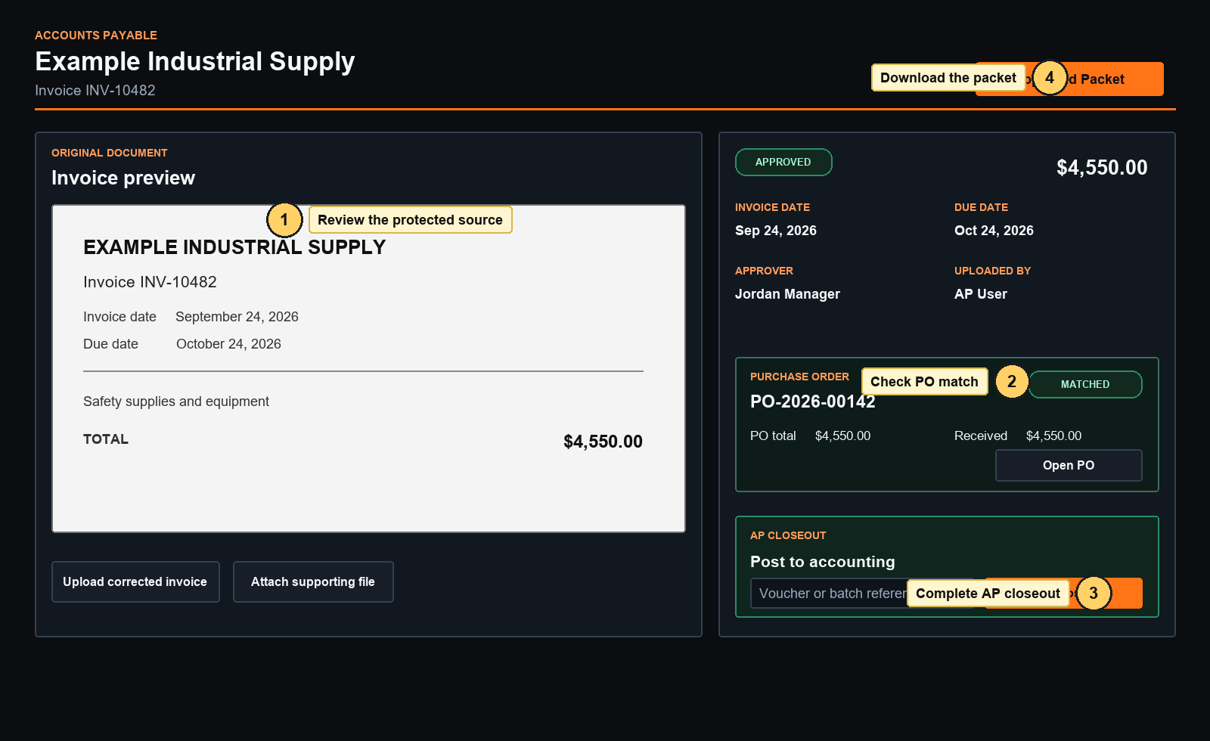
Figure 3 Invoice record and AP closeout
1 review the source | 2 check the optional PO match | 3 record closeout | 4 download the approved packet

Search and Run Reports
- Choose the tab that represents the status you want to report.
- Filter by vendor or invoice text, approver, and date range.
- Use Print or PDF for a readable status report.
- Use Export Excel for a detailed workbook of the filtered invoices.
- Use QuickBooks IIF for approved, posted, paid, or archived bills that are ready for QuickBooks Desktop import.

Notifications and Audit History
- The Recipients and Delivery section shows who received each workflow notification and whether email and push delivery succeeded.
- The Activity section records uploads, assignments, coding, returns, disputes, approvals, PO links, corrections, posting, payment, and archive actions with names and timestamps.
- Invoice files use protected links. Users cannot retrieve a file simply by guessing its address.

AP Completion Checklist
Checks 1 to 3 | Checks 4 to 6
1 Original and supporting files are present | 4 Authenticated approval is visible
2 Vendor, number, dates, and total are correct | 5 Posting and payment references are recorded
3 Approver and coding are correct | 6 The paid invoice is archived

